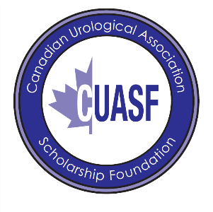
CUASF-Laborie Research Grant for Benign Prostatic Hyperplasia (BPH) Grant Program 2024-2025
APPLICATION INFORMATION
Section 1 – CV
Name (in full):
Date of birth:
Membership Number:
Citizenship:
Mailing Address:

Telephone # work:
Home:
Fax:
Section 2 – Proposed Research
Name of Institution and Department where applicant will conduct his/her academic/research activities

Academic Rank to be held by the applicant during tenure of the research

Name, address, and telephone number of the Department/Division Chairperson

Research Experience (a brief description of work in which the applicant has participated)

Briefly describe the environment and the research facilities

Briefly describe your long-term career plans and research objectives and how this project will impact these objectives

Section 3 – Authorization
By submitting this application, I agree to respect and follow the regulations that govern this Award, should it be successful.

Date: __________________ Place: __________________
Name of Applicant: __________________________________________
Application Checklist
- Completed Application Form
- Proposal not exceeding five (5) single spaced pages, which includes references, 12 fonts, 1-inch margins.
- Curriculum Vitae (Please submit a pdf version of your Common (CHIR) CV)
- Project budget
- Letter of support from the Department/Division Chair agreeing to conform to the Terms of Reference. The letter should indicate the level of support and commitment by the university/institution for the candidate.
- A detailed plan to apply for appropriate Ethics Committee approval and Regulatory approval (Clinical Trial Application in cases of non-marketed drugs or marketed drugs where the proposed use is outside the parameters of the Notice of Compliance) must be included along with the consent forms where human subjects are involved in the research project considered.
- A list of all current grants and submitted grant applications in the past 3 years (maximum of 1-2 pages) with the title of the grant, granting agency and amount of the grant.

Please email the completed application form plus supporting documents to marfisa.defrancesco@cua.org

