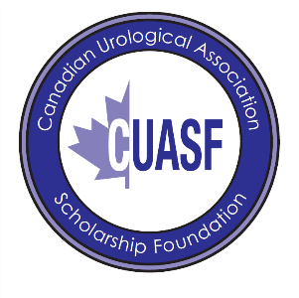

CUASF
RESEARCH GRANT FOR FEMALE PELVIC MEDICINE GRANT PROGRAM
APPLICATION INFORMATION
Section 1 – CV
Name (in full):
Date of birth:
Membership Number:
Citizenship:
Mailing Address:

Telephone # work:
Home:
Fax:
Section 2 – Proposed Research
Name of Institution and Department where applicant will conduct his/her academic/research activities

Academic Rank to be held by the applicant during tenure of the research

Name, address, and telephone number of the Department/Division Chairperson

Research Experience (a brief description of work in which the applicant has participated)

Briefly describe the environment and the research facilities

Briefly describe your long-term career plans and research objectives and how this project will impact these objectives

Section 3 – Authorization
By submitting this application, I agree to respect and follow the regulations that govern this Award, should it be successful.

Date: _________________ Place: __________________
Name of Applicant: __________________________________________
Application Checklist
- REB approval or proof of submission, if required depending on project methodology

- Letter of support from the Department/Division Chair

- Curriculum Vitae of the P.I. (and co-P.I., if applicable)

Please email the completed application form plus supporting documents to marfisa.defrancesco@cua.org

